Pg. 131 – 144, Java Programming *A comprehensive Introduction*

Class and Object expanded - Continued

**Section 1: Define / Answer**

Parameter: Parameters are the variables that are listed as part of a method declaration. Each parameter must have a unique name and a defined data type.

Argument: Arguments is a list of Parameters that can be passed to your Java Programm at start up.

Diagram a short code example of a method/parameter/argument in java? Explain what each piece of the code represents.

Public static int subtract(int I, int j) { //parameter

Return I – j;

}

Public static void main(String[] arg) {

Int I = 1;

Int j = 0;

Int subtract = subtract(I, j); arguments

}

1. Constructor (book definition): A Java class constructor initializes instances (objects) of that class. Typically, the constructor initializes the fields of the object that need initialization. Java constructors can also take parameters, so fields can be initialized in the object at creation time.

**Programming Assignment**

Task 1- Create a computer program that will calculate the fuel needed to go a specific number of miles for 3 different vehicles.

The program should create a “programmer created” class.

In the “programmer created” class set-up the program so it uses a parameterized method in the Vehicle class to return fuel needed for a specific distance. Allow user to manually enter distance.

Use a constructer with parameters to assign the values for passengers, fuel capacity, mpg.

Each Vehicle type should have unique values for number of passengers, fuel capacity, and miles per gallon.

Follow the sample below and return information on 3 vehicle types.

**Sample Output: // Create similar output for 3 Vehicle Types**

To go 252 miles a minivan needs 12.0 gallons of fuel.

The minivan carries: 7

The minivan has a fuel capacity of: 16

The minivan mpg: 21

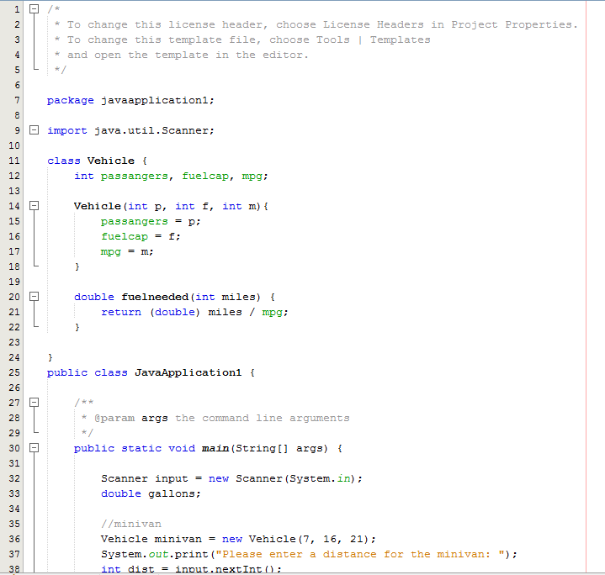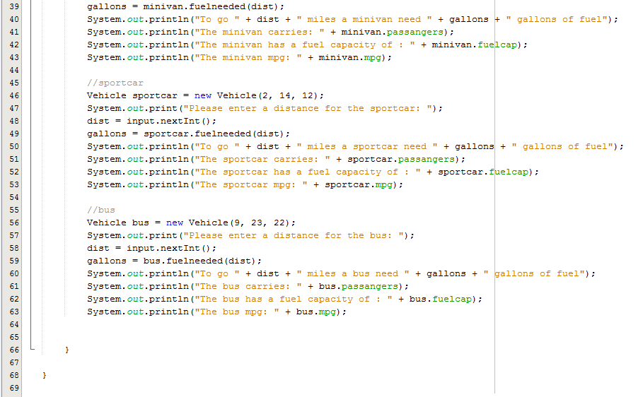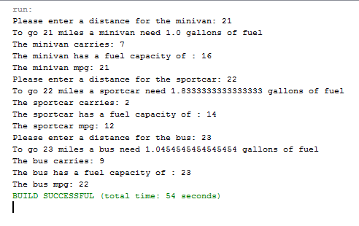

Task 2- Start to construct complete programs. Think about the overall functioning of the program. Use Assignment #12 Task1 as the bases for this exercise.

Create a **do**-**while** loop / with **switch case** statements that operate the program.

Present the user with a menu and options. Based upon the options selected by the user the program should operate correctly.

Create a computer program that will calculate the range for 3 different vehicles.

The program should create a “programmer created” class, where 3 **int** **objects** are created passengers, fuel capacity, mpg.

Set-up the program so the user can manually input the values for passengers, fuel capacity, mpg for the 3 created vehicles.

Create a **void** method inside the “programmer created “ class to calculate vehicle range**.**

**range =** **fuel capacity * miles per gallon**.

Each Vehicle type should have unique values for number of passengers, fuel capacity, and miles per gallon.

Attach Snipping photos as the program operates, including menu prompts, outputs etc.

**Sample Output: // Create similar output for 3 Vehicle Types**

**On next page-**

**Change input values now that we are creating the same program multiple times.**

**\*\*\*\*\*\*\*\*\*\*\*\*\*\*\*\*\*\*\*\*\*\*\*\*\*\*\*\*\*\*\*\*\*\*\*\*\*\***

**\* Main Menu: \***

**\* Enter # to run program or Quit \***

**\* 1) Enter Fuel Capacity \***

**\* 2) Enter Miles Per Gallon \***

**\* 3) Calculate Range \***

**\* 4) Quit \***

**\*\*\*\*\*\*\*\*\*\*\*\*\*\*\*\*\*\*\*\*\*\*\*\*\*\*\*\*\*\*\*\*\*\*\*\*\*\***

**1**

**You Selected Option 1:**

**Enter fuel capacity in Integers Please**

**25**

**You entered: 25**

**2**

**You Selected Option 2:**

**Enter Miles Per Gallon Please**

**29**

**You entered: 29**

The minivan carries= 8

The minivan has a fuel capacity of = 25

The minivan mpg =19

The minivan has a range of: 475 miles

